#### AndroCom: P2P Communication Without Internet

#### Wasia BCS203233

#### Muhammad Harris BCS203193

#### Umer Ahmed BCS203182



**Fall - 2023**

**Supervised By**

**Mr. Bilal Ahmed**

**Department of Computer Science**

**Capital University of Science & Technology, Islamabad**

|  |  |  |
| --- | --- | --- |
|  | Submission Form for Final-Year  PROJECT REPORT |  |

|  |  |  |  |  |  |  |
| --- | --- | --- | --- | --- | --- | --- |
| **Version** | | V 1.0 | |  | **NUMBER OF MEMBERS** |  |
|  | | | | | | |
| **TITLE** |  | | | | | |
|  | | | | | | |
| **SUPERVISOR NAME** | | |  | | | |

|  |  |  |
| --- | --- | --- |
| **MEMBER NAME** | **REG. NO.** | **EMAIL ADDRESS** |
|  |  |  |
|  |  |  |
|  |  |  |

|  |  |  |
| --- | --- | --- |
| **MEMBERS’ SIGNATURES** |  | |
|  |  | **Supervisor’s Signature** |
|  |  |
|  |  |

**Table of Contents**

**Chapter 1 Introduction** 5

1.1 Project Introduction 5

1.2 Existing Examples / Solutions 5

1.3 Business Scope 6

1.4 Useful Tools And Technologies 6

1.5 Project Work Breakdown 7

1.6 Project Timeline 8

**Chapter 2 Requirement Specification And Analysis** 9

2.1 Functional Requirements 9

2.2 Non-Functional Requirements 10

2.3 Selected Functional Requirements 10

2.4 System Use Case Modeling 11

2.5 System Sequence Diagrams 19

2.6 Domain Model 26

2.7 System Architecture 27

**Chapter 3 System Design** 29

3.1 Layer Definition 29

3.1.2 Application Layer 29

3.1.2 Network Layer 29

3.2 Software Architecture 30

3.3 Data Flow Diagram 31

3.4 User Interface Design 32

**List of Figures**

**Figure 1.1: Project Work Breakdown** 7

**Figure 1.2: Project Time Line** 8

**Figure 2.1: System Use Case Diagram** 11

**Figure 2.2: Establishing Connection With Microcontroller** 19

**Figure 2.3: Use Profile Setup** 20

**Figure 2.4: Sharing Active User Pool With User** 21

**Figure 2.5: Mute User Notification** 22

**Figure 2.6: Block or Unblock Other Users** 23

**Figure 2.7: Send Text Messages to Other Users** 24

**Figure 2.8: Making A Voice Call** 25

**Figure 2.9: Domain Model** 26

**Figure 2.10: System Design** 27

**Figure 2.11: System Architecture** 27

**Figure 3.1: Software Architecture Diagram** 30

**Figure 3.2: Data Flow Diagram** 31

**Figure 3.3: Splash Screen** 32

**Figure 3.4: Screen Upon Initial Laund** 32

**Figure 3.5: Profile Setup** 33

**Figure 3.6: Profile Setup (Filled)** 33

**Figure 3.7: Chats Screen** 34

**Figure 3.8: Call Log** 35

**Figure 3.9: Settings Menu** 36

**Figure 3.10: Message Screen** 37

**Figure 3.11: Other User’s Profile View** 38

**Figure 3.12: Incomming Voice Call Screen** 39

**Figure 3.13: Ongoing Voice Call Screen** 39

**Figure 3.14: Ongoing Video Call Screen** 39

**List of Tables**

**Table 2.1: Functional Requirements** 9

**Table 2.2: Non Functional Requirements** 10

**Table 2.3: Selected Functional Requirements** 10

**Table 2.4: Use Case 1** 12

**Table 2.5: Use Case 2** 13

**Table 2.6: Use Case 3** 14

**Table 2.7: Use Case 4** 15

**Table 2.8: Use Case 5** 16

**Table 2.9: Use Case 6** 17

**Table 2.10: Use Case 7** 17

**Table 3.1: Layer Definition** 29

# Chapter 1 Introduction

## Project Introduction

In today's world, the internet has become such an integral part of our lives that if it were to go down tomorrow, most forms of communication, such as messaging, calls, and video communication, would cease to function. AndroCom is an Android app that enables its users to send text messages, make voice calls, and engage in video calls with complete end-to-end encryption when communicating with other users without the need of an internet connection.

AndroCom has significant market potential due to its unique features. It can work in places with no internet, help universities with daily tasks, and serve as a reliable backup during internet outages or emergencies. Its versatility and special capabilities make it valuable in various situations, making it an important tool in the market.

This functionality is implemented through an AD HOC network that is created using a microcontroller, specifically a Raspberry Pi, which serves as a critical component of the system. A server is created on the Raspberry Pi using Python, enabling packet transfer between the Raspberry Pi and the devices using AndroCom. This innovative setup ensures secure and efficient communication while bypassing the need for a traditional internet connection, addressing the challenges posed by internet interruptions or limited access scenarios.

## Existing Examples / Solutions

At present, a noticeable gap exists in the market for apps that offer communication functionality independent of an internet connection. AndroCom, by enabling text messaging, voice calls and video calls with end-to-end encryption using Raspberry Pi, distinguishes itself as an innovative solution that fills this void. Unlike conventional applications that rely on internet connectivity, AndroCom offers users a novel approach to communication in scenarios where such connectivity may be unavailable or limited, addressing a critical need in today's interconnected world.

## Business Scope

The business scope of AndroCom is promising, offering a unique solution for communication in scenarios with limited or no internet access. It caters to a niche market and educational institutions, presents a valuable tool for disaster recovery and emergency services, and has the potential to serve as a backup communication service during internet outages. With its AD HOC networking capabilities, it can find use in various temporary gathering scenarios. The app's focus on data privacy and security also appeals to users prioritizing secure communication, while its potential global reach ensures a broad user base.

## Useful Tools and Technologies

Following is a list of technologies that are used for designing, development and testing phases of the project:

* Kotlin
* Java
* Android Studio
* Figma
* Raspberry Pi
* Python

In our application development, we will employ a hybrid approach, primarily utilizing Kotlin for its modern features and conciseness, while also integrating Java where necessary for specific algorithms, socket programming and several modules. Android Studio will serve as our development environment of choice, offering a comprehensive set of tools for efficient coding and testing. Notably, our app will not rely on an internet connection due to its offline functionality. An AD HOC network is created using Raspberry Pi with a server implemented in Python.

## Project Work Breakdown

A project work breakdown diagram is a way to break down a complex project into smaller, more manageable tasks. The project work breakdown for the AndroCom is given in *Figure 1.1*.

**Figure 1.1: Project Work Breakdown**

## Project Timeline

A project timeline diagram is a visual representation of the tasks and milestones in a project, showing their start and end dates. In simple words, it's a bar chart that shows when things need to happen in order for your project to finish on time. The project timeline for AndroCom is given in *Figure 1.2*.

**Figure 1.2: Project Time Line**

# 

# Chapter 2 Requirement Specification and Analysis

This chapter documents the specification and analysis of requirements for *AndroCom*. We have systematically sorted out the development requirements for the software, emphasizing the importance of identifying every small detail at this stage to prevent future software alterations.

This chapter covers the following specifications for the required software:

* Functional & Non-Functional Requirements
* Use Case Diagram
* Brief Description of Each Use Case
* Detailed Sequence Diagram for Each Use Case
* Domain Model
* System Architecture

## 2.1 Functional Requirements

Functional requirements are what a system must do to meet user needs. The functional requirements for AndroCom are given in *Table 2.1*.

**Table 2.1: Functional Requirements**

|  |  |  |  |
| --- | --- | --- | --- |
| **S. No.** | **Functional Requirement** | **Type** | **Status** |
| 1 | Configured microcontroller for network connection | Core | Incomplete |
| 2 | User profile setup in application | Core | Incomplete |
| 3 | List of active users connected with the network | Core | Incomplete |
| 4 | Block or unblock users | Intermediate | Incomplete |
| 5 | Mute messages and chat notifications of users | Intermediate | Incomplete |
| 6 | Text Messages with active users | Core | Incomplete |
| 7 | Voice Calls with active users | Core | Incomplete |
| 8 | Video Calls with active users | Core | Incomplete |
| 9 | Mute mic or turn-off camera when in call | Intermediate | Incomplete |
| 10 | Multicast broadcast by creating groups | Intermediate | Incomplete |
| 11 | Traffic Prioritization | Intermediate | Incomplete |

## 2.2 Non-Functional Requirements

Non-functional requirements are the constraints on how a system should work. The non-functional requirements for AndroCom are given in *Table 2.2.*

**Table 2.2: Functional and Non-Functional Requirement**

|  |  |  |
| --- | --- | --- |
| **S. No.** | **Non-Functional Requirements** | **Category** |
| 1 | Prompt when connected to the wrong network | Security |
| 2 | De-authorize unauthorized users | Security |
| 3 | End-to-End text encryption | Security |
| 4 | User friendly UI | Usability |
| 5 | View last seen time in active users list | Usability |
| 6 | View Signal Strength with network | Performance |
| 7 | Optimize resource usage on Microcontroller | Performance |
| 8 | Low consumption and Lightweight application | Performance |

## Selected Functional Requirements

The Selected function requirements of AndroCom for FYP Part-I are given in *Table 2.3.*

**Table 2.3: Selected Functional Requirement**

|  |  |  |
| --- | --- | --- |
| **S. No.** | **Functional Requirement** | **Type** |
| 1 | Configured microcontroller for network connection | Core |
| 2 | User profile setup in application | Core |
| 3 | List of active users connected with the network | Core |
| 4 | Block or unblock users | Intermediate |
| 5 | Mute message or call notifications of users | Intermediate |
| 6 | Text Messages with active users | Core |
| 7 | Voice Calls with active users | Core |

## System Use Case Modeling

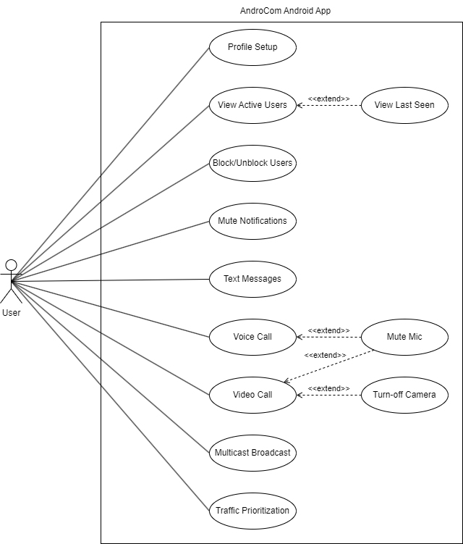A system use case diagram is a visual representation of the different ways that users can interact with a system. The system use case diagram of AndroCom is shown in *Figure 2.1.*

**Figure 2.1: System Use Case Diagram**

**Use Case 1 (Configured Microcontroller for Network Connection):**

**Table 2.4: Use Case 1**

|  |  |  |  |  |  |
| --- | --- | --- | --- | --- | --- |
| **Use Case ID:** | UC1 | | | | |
| **Use Case Name:** | Configured Microcontroller for network connection | | | | |
| **Created By:** | Wasia | | **Last Updated By:** | | Muhammad Harris |
| **Date Created:** | 22-10-2023 | | **Last Revision Date:** | | 29-10-2023 |
| **Actors:** | | User | | | |
| **Description:** | | The user will turn on the microcontroller and connect with its network on his android device | | | |
| **Trigger:** | | The user wants to create an ad hoc network | | | |
| **Preconditions:** | | The user has no internet and wants to use AndroCom for his communication | | | |
| **Post conditions:** | | An ad hoc network will be created via the microcontroller | | | |
| **Normal Flow:** | | User | | System | |
| 1.User turns on the microcontroller | | Microcontroller creates an ad hoc network | |
|  | | 2.User connects with ad hoc network via his android device | | User is connected with the network and is allowed to communicate on the network | |
| **Alternative Flows:** | | None | | | |
| **Exceptions:** | | 1. Microcontroller doesn’t turn on.  2. No network is created by the microcontroller.  3. Network doesn’t show on available networks list. | | | |

**Use Case 2 (User Profile Setup):**

**Table 2.5: Use Case 2**

|  |  |  |  |  |  |
| --- | --- | --- | --- | --- | --- |
| **Use Case ID:** | UC2 | | | | |
| **Use Case Name:** | User profile setup | | | | |
| **Created By:** | Umer Ahmed | | **Last Updated By:** | | Wasia |
| **Date Created:** | 22-10-2023 | | **Last Revision Date:** | | 30-10-2023 |
| **Actors:** | | User | | | |
| **Description:** | | The user will be presented with a sign-up screen where he enters their first name, last name and optionally uploads their profile picture in app. | | | |
| **Trigger:** | | The user installs the application and wishes to complete their profile setup. | | | |
| **Preconditions:** | | The user has successfully installed the application and is on the initial sign-up screen. | | | |
| **Post conditions:** | | The user’s profile information is saved and he can access, use their profile within application. | | | |
| **Normal Flow:** | | User | | System | |
| 1.User clicks get started button to request for sign-up. | | The system provides a User initial page for profile setup. | |
|  | | 2.User provide first name, last name and clicks continue. | | The system re-direct the User to a newly created profile page. | |
| **Alternative Flows:** | | The user cancels the profile setup. | | | |
| **Exceptions:** | | 1. The User has not filled the form correctly.  2. The system is not responding. | | | |

**Use Case 3 (List of active users connected with network):**

**Table 2.6: Use Case 3**

|  |  |  |  |  |  |
| --- | --- | --- | --- | --- | --- |
| **Use Case ID:** | UC3 | | | | |
| **Use Case Name:** | List of active users connected with network | | | | |
| **Created By:** | Wasia | | **Last Updated By:** | | Umer Ahmed |
| **Date Created:** | 22-10-2023 | | **Last Revision Date:** | | 30-10-2023 |
| **Actors:** | | User | | | |
| **Description:** | | System will provide a list of active users who are currently connected to the network for monitoring and management purposes. | | | |
| **Trigger:** | | The user selects the “Active Users” option from the application menu. | | | |
| **Preconditions:** | | User is logged into the application and a connection is established. | | | |
| **Post conditions:** | | The application displays a list of all active users connected to the network. | | | |
| **Normal Flow:** | | User | | System | |
| 1. The user selects the “Active Users” option from the application menu. | | The system displays the list of active users to the user. | |
| **Alternative Flows:** | | Network connection is not established and error message will be displayed. | | | |
| **Exceptions:** | | Network server is unavailable. | | | |

**Use Case 4 (Text messages with active users):**

**Table 2.7: Use Case 4**

|  |  |  |  |  |  |
| --- | --- | --- | --- | --- | --- |
| **Use Case ID:** | UC4 | | | | |
| **Use Case Name:** | Text messages with active users | | | | |
| **Created By:** | Muhammad Harris | | **Last Updated By:** | | Wasia |
| **Date Created:** | 22-10-2023 | | **Last Revision Date:** | | 30-10-2023 |
| **Actors:** | | User | | | |
| **Description:** | | User can send and receive text messages to other active users on the network. | | | |
| **Trigger:** | | The user selects the chat icon from the application menu. | | | |
| **Preconditions:** | | The user must be connected to network and is logged into the application. | | | |
| **Post conditions:** | | The user is able to send and receive text messages to other active users on a network. | | | |
| **Normal Flow:** | | User | | System | |
| 1. The user selects the chat icon from application menu. | | The system displays the chat section the application. | |
|  | | 2.The user selects the recipient of a text message. | | The system highlights selected recipient. | |
|  | | 3. The user enters the text message and sends it. | | The system send text message to the recipient over network. | |
| **Alternative Flows:** | | Recipient is not active and text message is not delivered. | | | |
| **Exceptions:** | | 1. User not logged into the application  2. Network server is unavailable. | | | |

**Use Case 5 (Block or unblock users):**

**Table 2.8: Use Case 5**

|  |  |  |  |  |  |
| --- | --- | --- | --- | --- | --- |
| **Use Case ID:** | UC5 | | | | |
| **Use Case Name:** | Block and unblock users | | | | |
| **Created By:** | Umer Ahmed | | **Last Updated By:** | | Wasia |
| **Date Created:** | 22-10-2023 | | **Last Revision Date:** | | 30-10-2023 |
| **Actors:** | | User | | | |
| **Description:** | | User can block and unblock other user within application. Blocking user will prevent further communication from or to the blocked user. | | | |
| **Trigger:** | | The user selects the “Block or unblock users” option from the application menu. | | | |
| **Preconditions:** | | User must be connected to network and is logged into the application interacting with the user whose status they want to change. | | | |
| **Post conditions:** | | The selected user is either blocked or unblocked, as per the user’s action. | | | |
| **Normal Flow:** | | User | | System | |
| 1. The user selects the “Block or unblock users” from application menu. | | The system displays a list of all active users on the network. | |
|  | | 2.The user selects the user they want to block or unblock. | | The system blocks or unblocks the selected user. | |
| **Alternative Flows:** | | User is already blocked or selected user is not active. | | | |
| **Exceptions:** | | 1. User not logged into the application.  2.Network connection is not established. | | | |

**Use Case 6 (Voice call with active users):**

**Table 2.9: Use Case 6**

|  |  |  |  |  |  |
| --- | --- | --- | --- | --- | --- |
| **Use Case ID:** | UC6 | | | | |
| **Use Case Name:** | Voice call with active users | | | | |
| **Created By:** | Umer Ahmed | | **Last Updated By:** | | Muhammad Harris |
| **Date Created:** | 10-10-2023 | | **Last Revision Date:** | | 11-10-2023 |
| **Actors:** | | User | | | |
| **Description:** | | User can initiate and receive a voice call from an active user within application. | | | |
| **Trigger:** | | The user will press the call icon from the text chat section. | | | |
| **Preconditions:** | | User must be connected to network and is logged into the application. The user has selected an active user from the list and indicated to make a voice call. | | | |
| **Post conditions:** | | The user is able to a voice call with another active user on the network. | | | |
| **Normal Flow:** | | User | | System | |
| 1. The user selects the recipient of the voice call and initiates the voice call. | | The system sends a voice call request to the recipient over the network. | |
|  | | 2. The users are able to talk to each other over the voice connection. | | The system establishes a voice connection between two users. | |
| **Alternative Flows:** | | The recipient user rejects the voice call request and call is not established. | | | |
| **Exceptions:** | | 1. User not logged into the application.  2.Selected active user is no longer available or active. | | | |

**Use Case 7 (mute messages and call notifications of users):**

**Table 2.10: Use Case 7**

|  |  |  |  |  |  |
| --- | --- | --- | --- | --- | --- |
| **Use Case ID:** | UC7 | | | | |
| **Use Case Name:** | Mute messages and call notifications of users | | | | |
| **Created By:** | Wasia | | **Last Updated By:** | | Muhammad Harris |
| **Date Created:** | 10-10-2023 | | **Last Revision Date:** | | 19-10-2023 |
| **Actors:** | | User | | | |
| **Description:** | | User can mute messages and call notifications of specific users within application. | | | |
| **Trigger:** | | The user selects the “Mute messages and call notification” option from the settings or user preferences section. | | | |
| **Preconditions:** | | User must be connected to network and is logged into the application. Also, user has identified specific users from whom they want to mute notifications. | | | |
| **Post conditions:** | | The selected user’s message and call notifications are either muted or unmuted, as per user’s action. | | | |
| **Normal Flow:** | | User | | System | |
| 1. The user selects the “Mute messages and call notifications” option. | | The system displays a list of all active users on the network. | |
|  | | 2. The user selects the users whose messages and call notifications they want to mute. | | The system mutes messages and call notifications from the selected user. | |
| **Alternative Flows:** | | The selected user is already muted or a user is not active. | | | |
| **Exceptions:** | | 1. User not logged into the application and is not connected to the network. | | | |

## System Sequence Diagrams

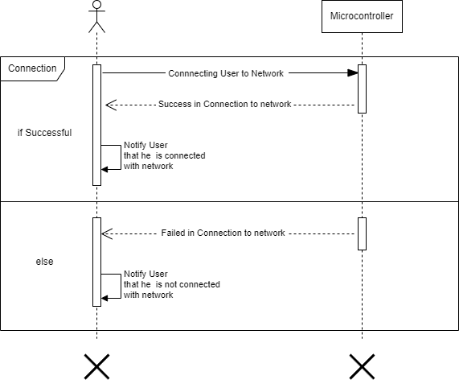A system use case sequence diagram is a visual representation of the steps involved in a particular use case of a system, showing the interactions between the different actors and components of the system. Following are the sequence diagrams for AndroCom application.

**Figure 2.2: Establishing connection with microcontroller**

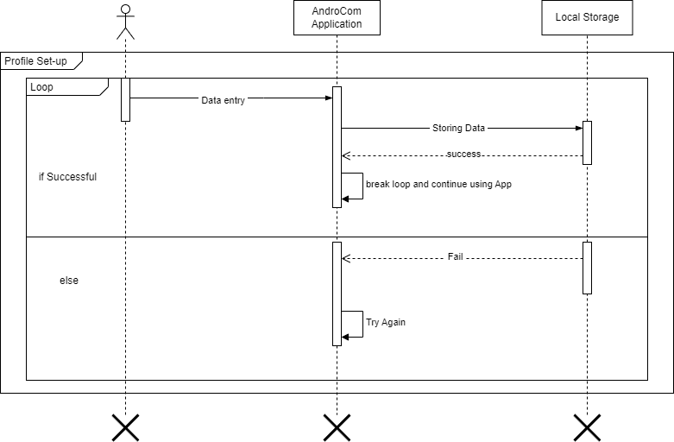

**Figure 2.3: User profile setup**

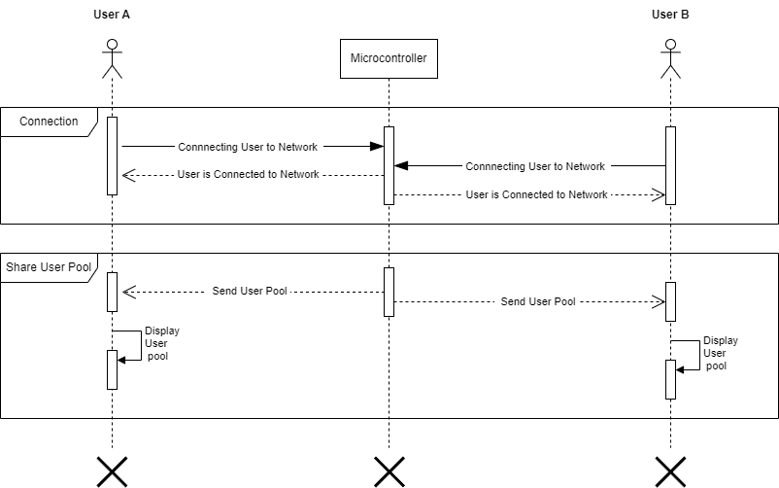

**Figure 2.4: Sharing active user pool with user**

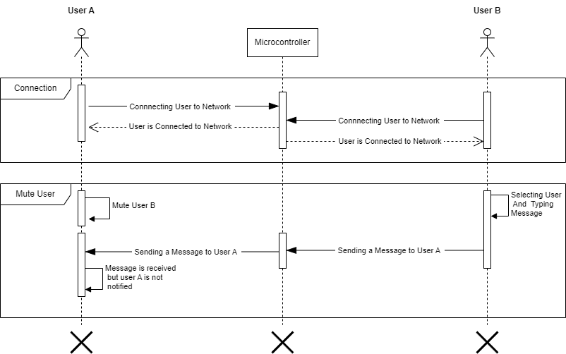

**Figure 2.5: Mute user notifications**

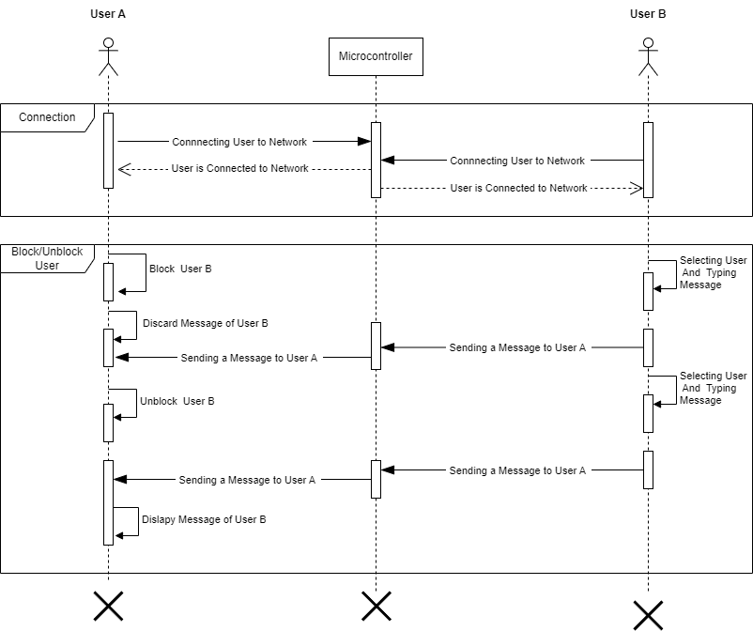

**Figure 2.6: Block or Unblock other users**

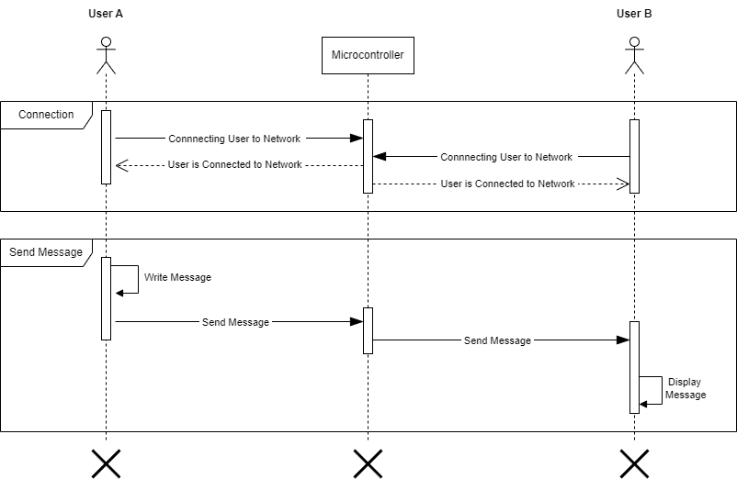

**Figure 2.7: Send text message to other users**

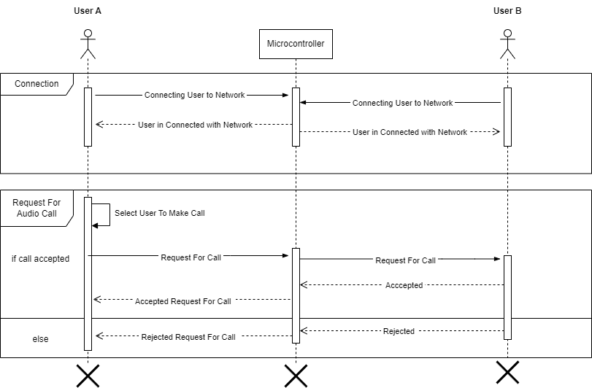

**Figure 2.8: Making a voice call**

## Domain Model

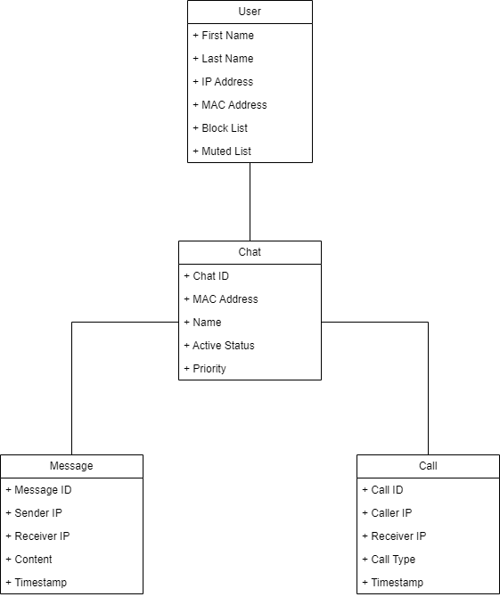A domain model is a conceptual map of the key concepts and relationships in a problem domain. Domain models are used to help developers understand and design software. The domain model for AndroCom is given below in *figure 2.9.*

**Figure 2.9: Domain Model**

## 2.7 System Architecture

The system architecture of AndroCom is designed to provide a reliable and secure way for users to communicate without an internet connection. The system consists of a client app and a microcontroller. The client app is responsible for establishing a connection to the AD HOC network, sending and receiving messages, and making and receiving voice and video calls. The microcontroller is responsible for managing the AD HOC network and relaying messages between clients. The microcontroller is very portable and can be attached to transport vehicles and drones.

The client app and the server communicate with each other using TCP/IP sockets. The server also uses UDP sockets to broadcast messages to all clients on the AD HOC network.

The system architecture and system design are shown in *figure 10.10* and *figure 10.11.*

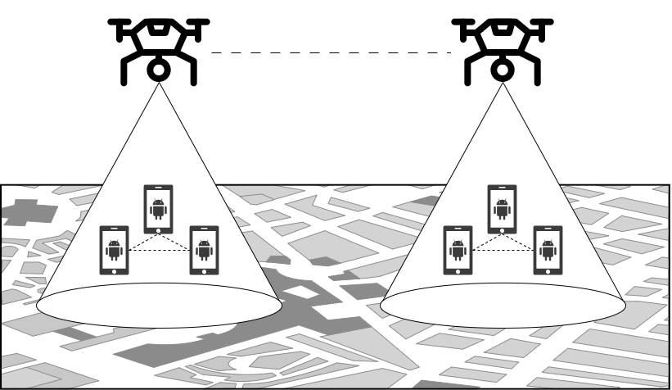

**Figure 2.10: System Design**

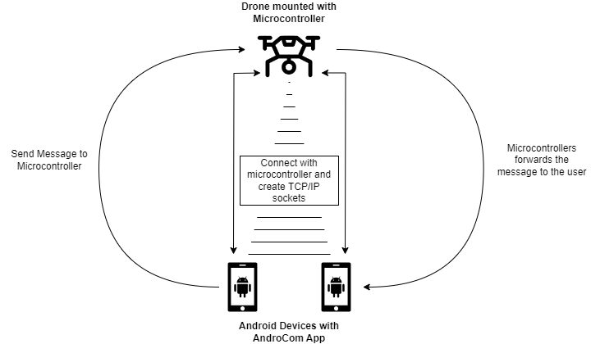

**Figure 2.11: System Architecture**

# Chapter 3 System Design

The purpose of this chapter is to provide information that is complementary to the code. Without an adequate design that delivers required function as well as quality attributes, the project will fail. But communicating architecture to its stakeholders is as important a job as creating it in the first place.

This chapter covers the following specifications for the required software:

* Layer Definition
* Software Architecture
* Data Flow Diagram
* User Interface Design

## 3.1 Layer Definition

A layer definition is a description of the purpose, functionality, and interfaces of a layer in a layered system. In simple words, it is a definition of what a layer does and how it interacts with other layers. Layer definition for AndroCom is given in *Table 3.1.*

**Table 3.1: Layer Definition**

|  |  |
| --- | --- |
| **Layers** | **Description** |
| Application Layer (AndroCom App) | This layer is responsible for providing user interfaces and other key functionalities. |
| Network Layer (Microcontroller) | This layer is responsible for communicating with the microcontroller over a network. |

## 3.1.2 Application Layer

This layer is responsible for implementing the core functionality of the application, such as connecting sockets, sending and receiving messages, making & receiving voice and video calls, and interacting with the user interface.

## 3.1.2 Network Layer

This layer is responsible for communicating with the microcontroller over a network. The AndroCom App layer sends and receives messages to and from the network layer. The network layer then sends and receives messages to and from the microcontroller.

## Software Architecture

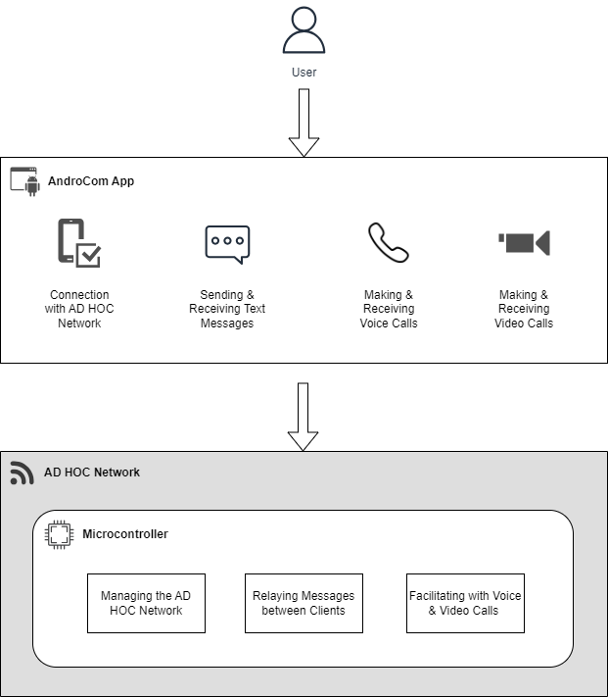A software architecture diagram is a visual representation of the structure of a software system, showing the components of the system and how they interact. In simpler words, it is a diagram that shows how a software system is built. The software architecture diagram is given below in *figure 3.1.*

**Figure 3.1: Software Architecture Diagram**

## Data Flow Diagram

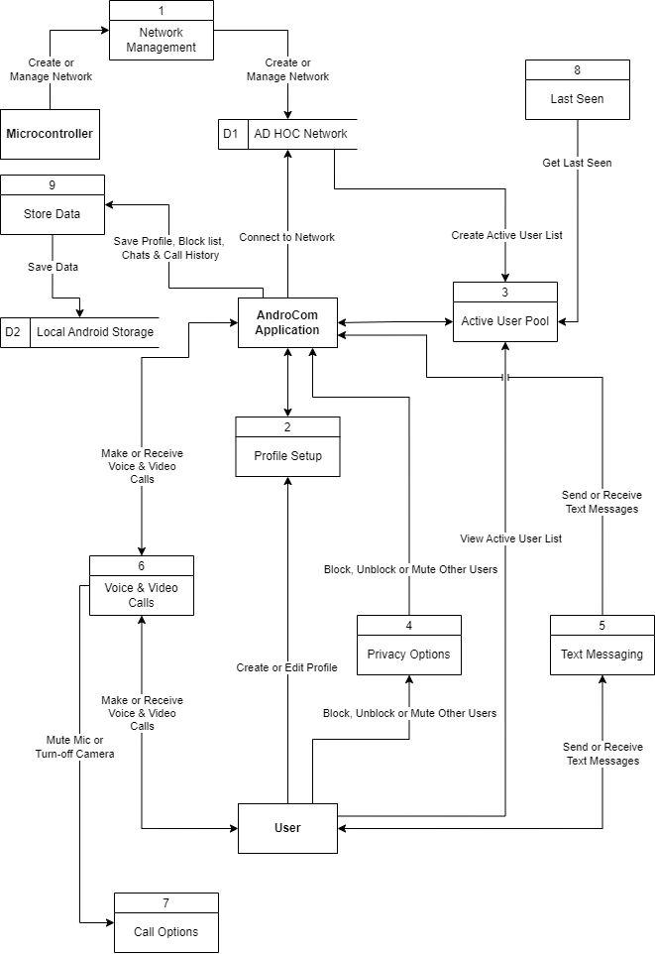A Data Flow Diagram is a graphical representation of the flow of data through a system, showing its inputs, outputs, and processing steps. The data flow diagram for AndroCom is given in *figure 3.2.*

**Figure 3.2: Data Flow Diagram**

## User Interface Design

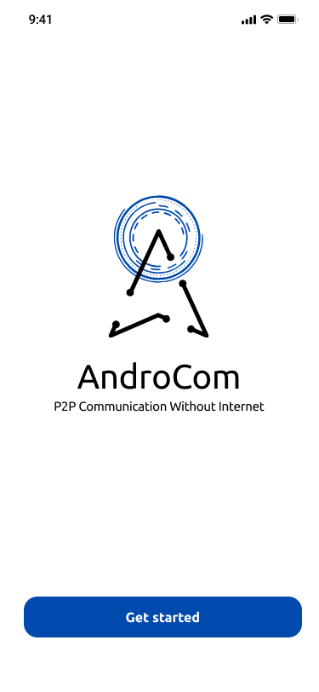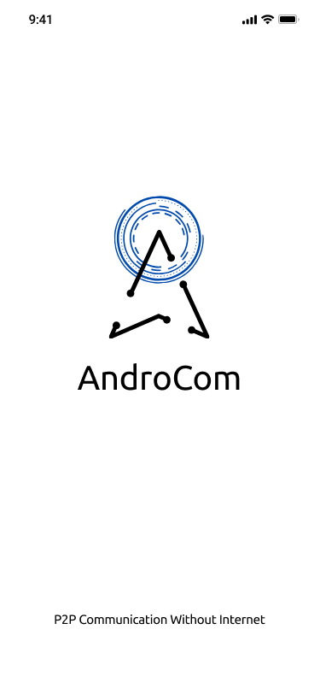User interface design is the process of creating interactive screens that are easy to use and understand. The UI design for AndroCom is given below.

**Figure 3.4: Screen upon initial launch**

**Figure 3.3: Splash Screen**

**Description:**

The AndroCom app's splash screen is the first thing users see when they open the app. It displays the app's logo in the center against a white background. This screen creates a strong initial impression and sets the stage for the user's interaction with the app.

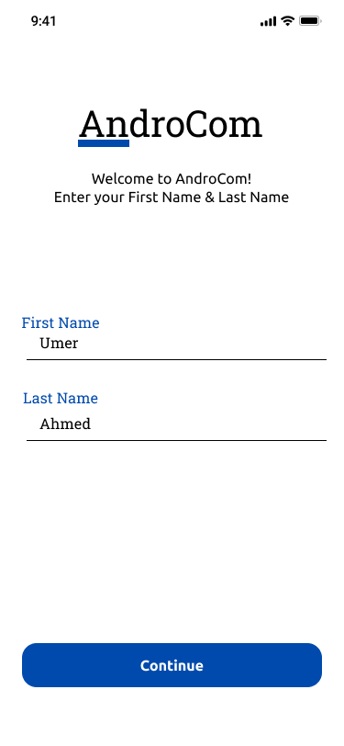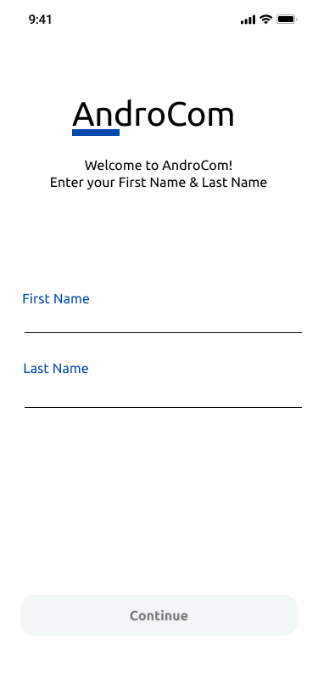

**Figure 3.6: Profile Setup (filled)**

**Figure 3.5: Profile Setup**

**Description:**

The profile setup screen in AndroCom is where users enter their first name and last name. It's a clean and minimalist design, with input fields for both names. What's distinctive is the 'Next' button, which remains inactive until both fields are filled. This encourages users to provide their information, ensuring a complete profile setup.

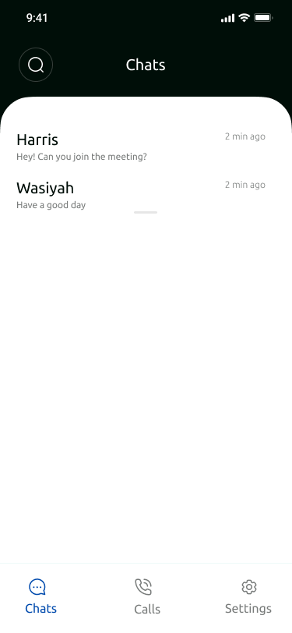

**Figure 3.7: Chats Screen**

**Description:**

The chat screen in AndroCom is where users can seamlessly engage in multiple conversations. The user-friendly interface allows users to view and manage various chat threads.

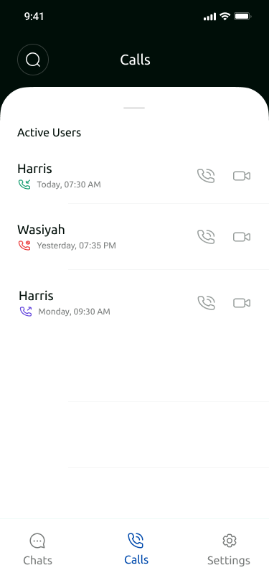**Description:**

**Figure 3.8: Call Log**

The call log screen in AndroCom provides users with a comprehensive record of their recent calls and also displays active users with whom call can be made.

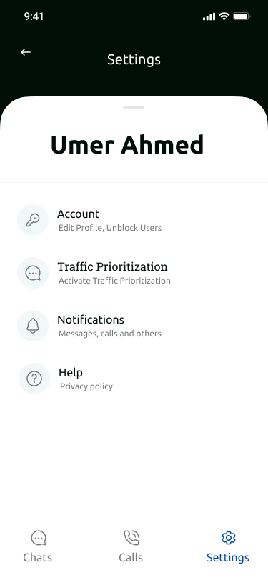**Description:**

**Figure 3.9: Settings Menu**

The settings screen in AndroCom is where you can easily view and edit your display name, unblock users, activate network prioritization, adjust notification settings, and access the privacy policy and manual.

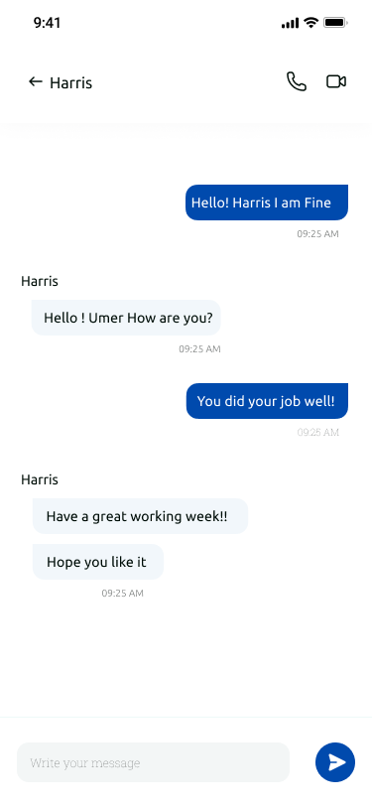**Description:**

**Figure 3.10: Message Screen**

The messaging screen in AndroCom is where you can scroll through older messages and send new ones to active users. Also, you can make voice and video calls directly from this screen, ensuring that your communication needs are all in one place.

**Figure 3.11: Other User's Profile View**

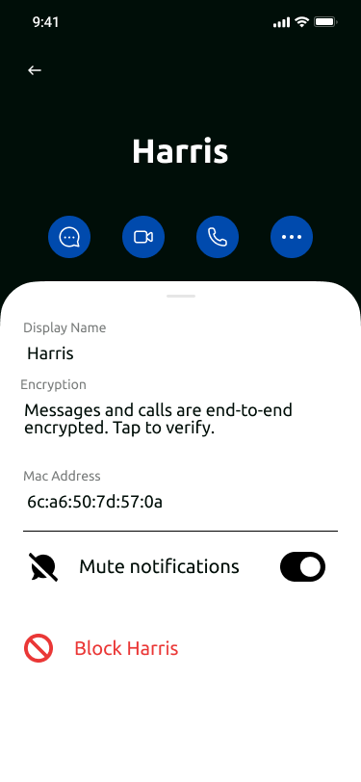**Description:**

When viewing another person's profile in AndroCom, you'll find essential information at a glance. This includes their name and MAC address, making it easy to identify and connect with them. Additionally, you have the option to mute or block the user.

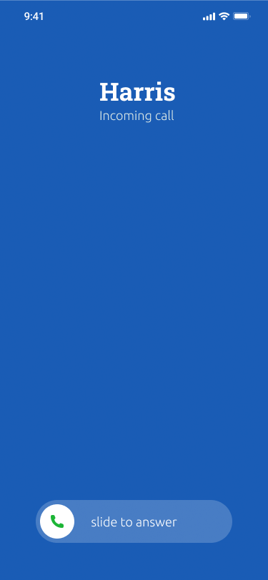**Description:**

**Figure 3.14: Ongoing Video Call Screen**

**Figure 3.13: Ongoing Voice Call Screen**

**Figure 3.12: Incoming Voice Call Screen**

In AndroCom, when you receive an incoming voice call, the caller's name is prominently displayed. By sliding, you can accept the call. During an ongoing voice call, you have the option to mute your microphone for privacy and convenience. And for video calls, you can mute the microphone or disable the camera.